Continuing Education

North Carolina Board of Examiners for Nursing Home Administrators and North Carolina Division of Health Service Regulation and Adult Care Licensure
A maximum of 11.5 hours of continuing education credit for Nursing Home Administrators may be earned by attending all sessions. Each educational session will be applied for separately and every session attended will be credited with CEUs. Credit is applied for through the North Carolina Board of Examiners for Nursing Home Administrators and the North Carolina Division of Health Service Regulation for Adult Care Licensure.

National Association of State Boards of Accountancy
A total of 13.0 continuing professional education hours will be applied for through the National Association of State Boards of Accountancy. LeadingAge North Carolina is registered with the National Association of State Boards of Accountancy (NASBA) as a sponsor of continuing professional education on the National Registry of CPE Sponsors. State boards of accountancy have final authority on the acceptance of individual courses for CPE credit. Complaints regarding registered sponsors may be submitted to the National Registry of CPE Sponsors through its website: www.NASBARegistry.org. All sessions are basic level, with no prerequisites and/or advance preparation required. All sessions are classified as specialized knowledge field of study. Delivery method is Group-Live.

National Association of Long Term Care Administrator Boards
This program has been approved for Continuing Education for 11.5 total participant hours by NAB/NCERS—Approval # 20270505-37.50-A120617-IN
LeadingAge North Carolina is responsible for reporting attendance information to NAB. Certificates will be emailed within 30 days of the conference and attendance information uploaded to the NAB registry during the same time frame. You must provide your Registry ID number on the certificate of attendance form; we cannot report attendance without this information. LeadingAge NC will not make any changes to attendance information or issue new certificates once attendance is reported to NAB.
HR Certification Institute
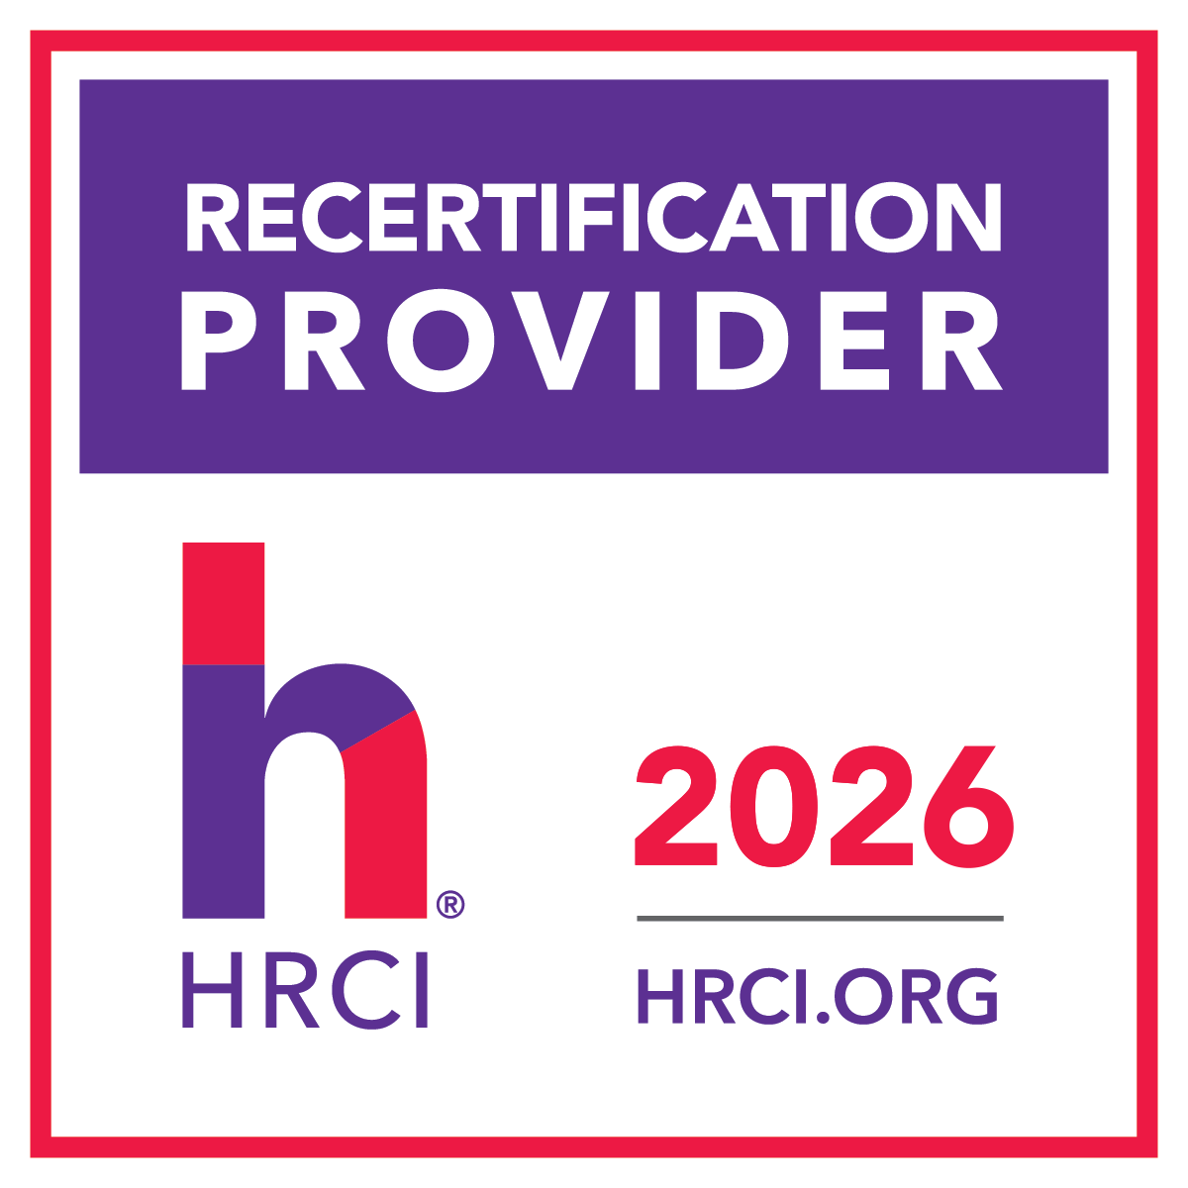
This Program, ID No. 738438, has been approved for 11.5 HR (General) recertification credit hours toward aPHR®, aPHRi™ , PHR®, PHRca®, SPHR®, GPHR®, PHRi ™ , and SPHRi™ recertification through the HR Certification Institute. Please make note of the activity ID number on your recertification application form. For more information about certification or recertification, please visit the HR Certification Institute website at www.hrci.org

American Nurses Credentialing Center’s Commission on Accreditation
This activity has been submitted to the Wisconsin Nurses Association for approval to award contact hours. The Wisconsin Nurses Association is accredited as an approver of nursing continuing professional development by the American Nurses Credentialing Center’s Commission on Accreditation.

In order to receive credit, participants must
- Stay for the entire session.
- Complete an online evaluation* for each session attended, to include name and contact information.
- Submit continuing education form. In order to report attendance records to licensure bodies in the required timeframe, the association will not accept forms submitted after May 22.
*Evaluation form must be completed within 24 hours of the session. Once the portal is closed, it can not be re-opened.
Certificates of Attendance and CEU Certificates will be mailed within 30 days post conference.

